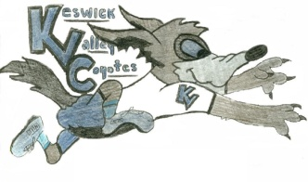KVMS May 11th to May 15th Game Challenge
What is it?
Try selected games from these utube videos each day. The videos were done by Physical Education teachers around the province. There are more games to come! Write the names of the games down on paper or in an email and how many minutes you played them. Do this Monday through Friday this week and email crystal.bourgoin@nbed.nb.ca at the end of the week with your activity list and vote on your favorite game. If your class is on teams you can send it to me that way too. A prize will be drawn the following Monday for all those who share!
What is this channel?
https://www.youtube.com/playlist?list=PL2ZiLbnHH6WHuRjrVolbiVpk-Lv2giMK-
This utube channel was designed by the New Brunswick Physical Education Society. This is a group of Physical Education teachers who know how important it is to stay active and well. The goal is to create a variety of games to help students stay active while having to stay at home. Most of the games are done with very little equipment.
Challenge 1 winner: Josh Brewer (Share an activity you are doing to stay active)
Challenge 2 winners: Jordis and Jessie (Activity Tracker check in)
Challenge 3 winner: We will find out on Monday (BINGO Game)
Challenge 4: winner: TBA
Feel free to email me with any questions or if you would like any other skills or games to work on! I always have lots to share and love hearing from all of you! crystal.bourgoin@nbed.nb.ca

